Hotel City Green Berlin

Bruno-Taut-Strasse 4-6, 12524 Berlin

+49 30 896 290 32

<https://www.city-green.berlin/buchen/>

Has 166 rooms with 1- or 2-beds.

4,1 km from the sports facility

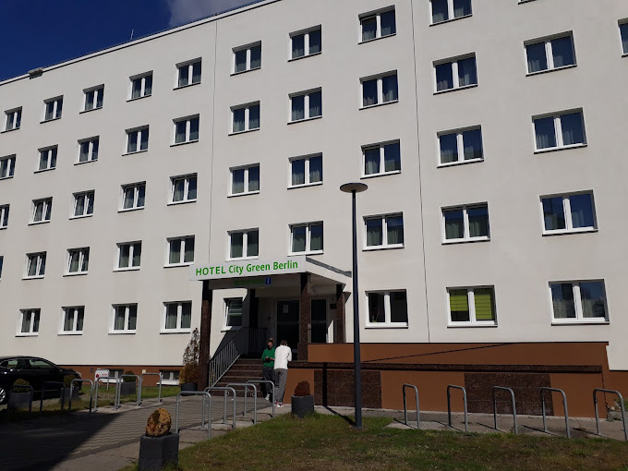

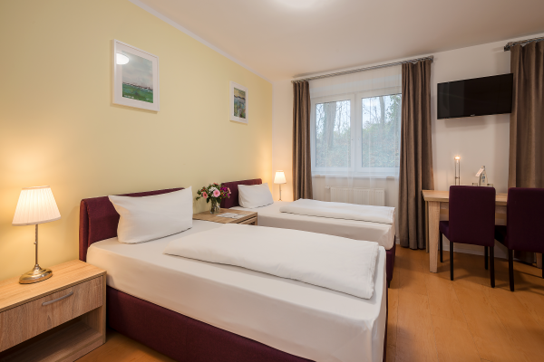

Prices starts from 65 €