NEOHOSTEL

Grünauer Str. 192, 12557 Berlin

+49 30 509 301 550

<https://www.neohostel.com/>

It has rooms with 2-, 4- or 6-beds.

4 km from the sports facility

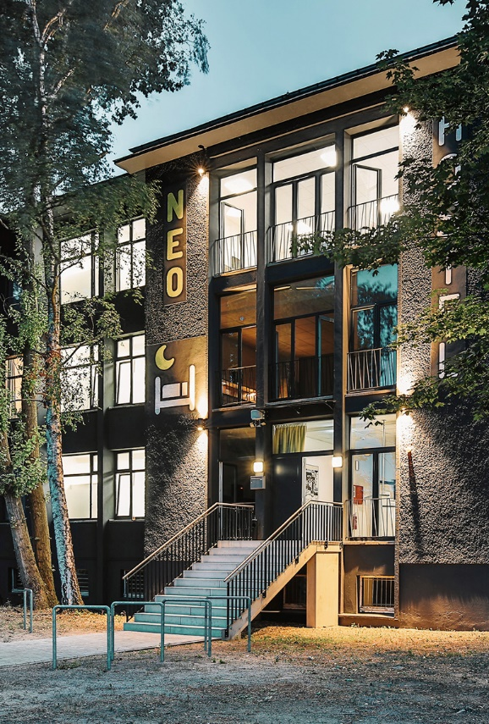

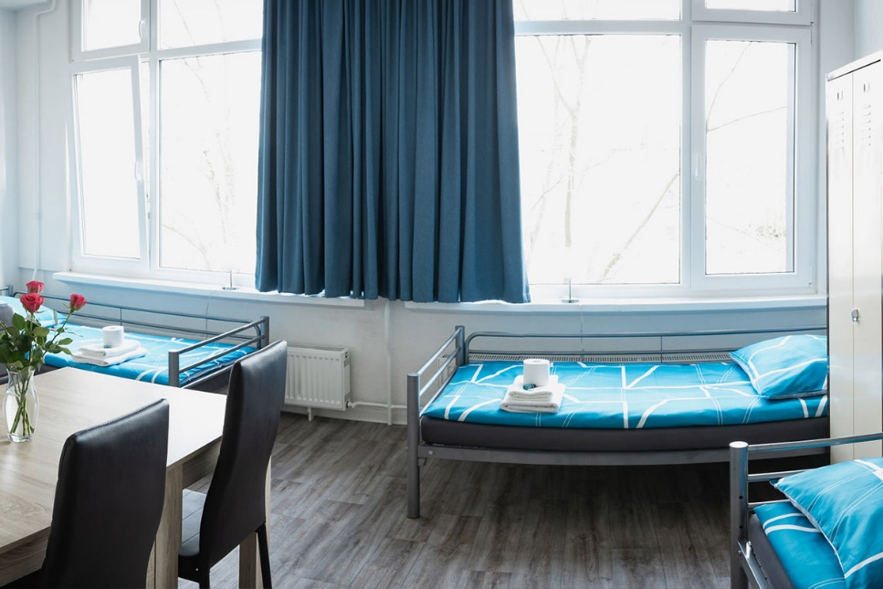

Prices starts from 35 €